# SkiTracker App Documentation

**Introduction:**

The SkiTracker app is designed to cater skiing enthusiasts who seek a user-friendly and aesthetically pleasing solution for tracking their skiing adventures. The motivation behind the app stems from the lack of modern and well-designed alternatives in the market, especially those requiring a financial commitment.

**Main Idea:**

The primary goal of SkiTracker is to provide users with a comprehensive tool for tracking their skiing routes, capturing key metrics such as distance covered, speed, and elevation changes. The app aims to enhance the skiing experience by offering a visually appealing interface and robust functionality, ensuring users can relive and share their memorable skiing moments.

**Objectives:**

Route tracking: Allows users to track their own ski routes in real time and visualise the route travelled on a map within the app.

Other: Recording of other data such as distance travelled, average and maximum speed and differences in altitude during skiing.

Data logging: Allows users to view their ski history and view a log of previous sessions and performances.

**Design:**

The design of the SkiTracker app was created with the help of Figma. After the design was finalised in Figma, I tried to implement the design in Android Studio. The transition from design to development went quite well.

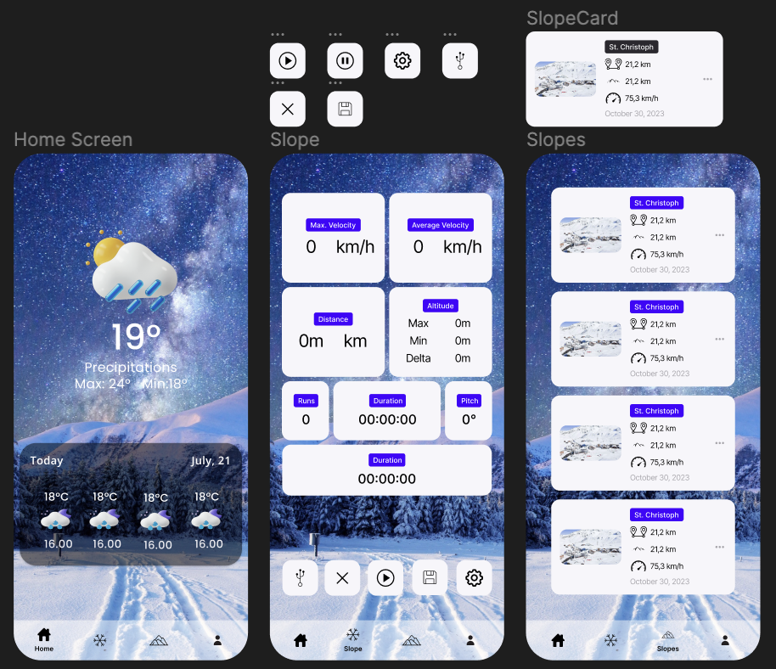

Android Studio:

**Conclusion:**

To summarise, the development of the SkiTracker app is going well and I have already made good progress. The combination of Figma for the design and Android Studio for the development has proven to be a pleasant one.